THETA PROVINCE CONVENTION
October 4, 2025

The Theta Province Convention of Delta Theta Tau Sorority, Inc. convened at 9:00 A.M, October 4, 2025 at New Harmony Inn and Conference Center, New Harmony, IN.

WELCOME
Province Chairman Lorie Hacker brought the meeting to order with introductions of the 2025 Convention Chairman, Carla Bowman, Eta Beta, Odon, IN. Carla introduced the Director of Guest Services from the New Harmony Inn and Conference Center.

The Province Chairman opened the business meeting with the Delta Opening Ceremony and Delta Prayer.

INITIATION CEREMONY
The Chair introduced Julie Callis, Past National President, Lambda Theta, Martinsville, IN and her team conducted the Initiation Service for one new member. Lorie Hacker welcomed Susan Johnston as a member of Nu Tau Chapter, Greenwood, IN.

MEMORIAL SERVICE
National Vice President, Junior Cruea, Kappa Xi, Brookville, OH conducted the Memorial Service for the following Delta Sisters:

- Margaret Ann Cooper, MAL, Epsilon Psi, Vincennes, IN 2022
- Maxine Hamilton, MAL, Beta Kappa-Alpha Alumnae Assoc, October 24, 2024
- Shirley Lyster, Beta Kappa, June 2024
- Jane Pugh, MAL, Beta Kappa-Alpha Alumnae Assoc, September 20, 2024
- Dorothy Small, MAL, Theta Gamma-Alpha, Bloomfield, IN, July 14, 2024
- Susan Holtsclaw, MAL, Theta Gamma-Alpha, Bloomfield, IN, August 7, 2024
- Sylvia Barger, MAL, Lambda Eta-Alpha, Franklin, IN, September 19, 2024
- Ruth Wescott, Lambda Eta-Alpha, Franklin, IN, September 3, 2025
- Rosemary Williams, MAL, Lambda Theta, Martinsville, IN, October 24, 2024
- Marilyn Rosenbaum, MAL, Lambda Theta, Martinsville, IN, March 14, 2025
- Becky Meyer, Eta Kappa, Brookville, IN, December 22, 2024
- Roxanne Schutt, MAL, Zeta Lambda, Shelbyville, IN, December 30, 2024
- Jane Ann Brinley, MAL, Pi Beta, Richmond, IN, January 9, 2025
- Janet Donham, MAL, Zeta, Bloomington, IN, February 6, 2025
- Tonya Rensi, MAL, Zeta, Bloomington, IN, 2025
- Margaret Tucker, MAL, Iota Chi, Spencer, IN, February 14, 2025
- Karen Hachmeister Sureck, Nu Theta, Boonville, IN, June 25, 2025
- Betty Jo Inman, Xi Nu-Alpha, Owensburg, IN, July 17, 2025
- Sondra Rehmel, Pi-Alpha, Jasonville, IN, March 20, 2025

OBJECT OF THE PROVINCE
The Convention Secretary, Connie Holzhausen, Lambda Eta, Franklin, IN, read the object of the Province.

INTRODUCTIONS
The Chair introduced the National Officers who were present at our convention.
- Kris Trapp, National President, Tau, Valparaiso, IN
- Junior Cruea, Vice President, Kappa Xi, Brookville, OH
- Evonne Albert, Chairman of the Board of Trustees, Xi Phi, Marissa, IL
- Dana Anderson, Secretary of the Board of Trustees, Gamma Pi, New Paris, OH
- Debi Hamblet, National Secretary, Lambda Nu, Mooresville, IN
- Beth Wallis, Executive Secretary and Honorary Member, Lambda Theta, Martinsville, IN
- Doris Sanders, Editor of GRIT, Zeta Lambda, Shelbyville, IN

The Chair introduced Past National Officers and National Committee Members.
- Terri Reister, 2022 Past National President and 2026 National Convention Coordinator, Lambda Nu, Mooresville, IN
- Julie Callis, 2023 Past National President, Lambda Theta, Martinsville, IN
- Mary Beth Godsey, 2021 Past National Officer, Zeta, Bloomington, IN
- Connie Holzhausen, 2004 Past National Officer, Lambda Eta, Franklin, IN
- Marcia Swift, Board Member of Delta Home and Past Theta PEG, Zeta Lambda, Shelbyville, IN

The Chair introduced Past Theta Province Chairmen.
- Veanna Kessler, 2014 Past Province Chairman, Zeta Lambda, Shelbyville, IN
- Doris Sanders, 2000 and 2015 Past Province Chairman, Zeta Lambda, Shelbyville, IN
- Donna Justice, 2009 and 2016 Past Province Chairman, Lambda Eta, Franklin, IN
- Emily Query, 2020 and 2021 Past Province Chairman, Kappa Mu, Carlisle, IN
- Connie Holzhausen, 1997 and 2022 Past Province Chairman, Lambda Eta, Franklin, IN
- Marylynne Winslow, 2023 Past Province Chairman, Nu Tau, Greenwood, IN
- Kim Hart, 2024 Past Province Chairman, Lambda Theta, Martinsville, IN

The Chair introduced Deltas serving this convention.
- Sergeant-at-Arms, Dana Marietta, Lambda Eta, Franklin, IN
- Assistant Sergeant-at-Arms, Kelley Hartman, Lambda Eta, Franklin, IN
- Convention Secretary, Connie Holzhausen, Lambda Eta, Franklin, IN
- Teller, Rebecca Sims, Theta Zeta, Seymour, IN
- Page, Robin Randolph-DeClue, Nu Tau, Greenwood, IN
- Standing Rules Committee
  - Jan Johnson, Chairman, Lambda Eta, Franklin, IN
  - Kim Frazier, Iota Chi, Spencer, IN
  - Marcia Swift, Zeta Lambda, Shelbyville, IN
- Province Philanthropy Committee
  - Kim Hart, Chairman, Lambda Theta, Martinsville, IN
  - Kelley Hartman, Lambda Eta, Franklin, IN
  - Mary Beth Godsey, Zeta, Bloomington, IN
The Chair asked if there was any objection to changing the order of business if deemed advisable. There were no objections.

MINUTES
The Chair announced that the minutes of the 2024 Province Convention were approved by the Assigned Officer and will not be read unless desired. There was no request that the minutes be read.

ROLL CALL
The Convention Secretary called the roll.
- Zeta - Bloomington, IN
- Gamma Gamma - Washington, IN
- Epsilon Mu - Sullivan, IN
- Zeta Lambda - Shelbyville, IN
- Eta Beta - Odon, IN
- Eta Kappa - Brookville, IN
- Theta Zeta - Seymour, IN
- Iota Chi - Spencer, IN
- Kappa Mu - Carlisle, IN
- Lambda Eta - Franklin, IN
- Lambda Theta - Martinsville, IN
- Nu Tau - Greenwood, IN
- Omicron Omega - Murfreesboro, TN
- Doris Sanders, 2015 Past Province Chairman
- Donna Justice, 2016 Past Province Chairman
- Emily Query, 2020 and 2021 Past Province Chairman
- Connie Holzhausen, 2022 Past Province Chairman
- Marylynne Winslow, 2023 Past Province Chairman
- Kim Hart, 2024 Past Province Chairman
- Julie Callis, 2023 Past National President
- Beth Wallis, Honorary Member
- Lorie Hacker, 2025 Province Chairman
There are 20 voting members present. Two voting members have two votes due to the fact they are a Past Province Chairman and a delegate. Therefore, there are 22 eligible votes. The Chair declared a quorum established.

CONVENTION RULES
The Chair introduced Jan Johnson, Lambda Eta, Franklin, IN Chairman of the Standing Rules and Convention Rules Committee. Jan read the Convention Rules and moved that they be adopted.

STANDING RULES
There was one piece of legislation introduced for the change of Theta Province Standing Rules. Jan Johnson, Lambda Eta, Franklin, IN gave the report of the Standing Rules Committee.
Amendment 1: Article II - Province Convention
Present Wording: 2. Voting members shall consist of the Chapter delegates, Province Chairman, Past Province Chairmen for ten (10) years following their serving as Province Chairman, Past National Presidents and Honorary Members of the Province.
Proposed Wording: 2. Voting members shall consist of the Chapter delegates, Province Chairman, Past Province Chairmen for five (5) years following their service as Province Chairman, Past National Presidents and Honorary Members of the Province.
Rationale: With the amount of chapters we have in our Province, allowing so many Past Province Chairmen to vote reduces the voting power of the delegates. Depending on attendance at any given Province Convention, there could be more Past Province Chairmen and Past National President votes than Delegate votes.
Submitted by Lambda Eta, Franklin, IN
There was not a ⅔ vote in the affirmative and the amendment was not adopted.

PHILANTHROPY PROJECT PRESENTATIONS
Kim Hart, Chairman, Lambda Theta, Martinsville, IN gave her report on behalf of the members of her committee. Three projects were submitted for consideration:
- Indiana Donor Network Foundation, Speaker: Maddy Shotts
- SAWS (Servants at Work, Inc.), Speaker: Rick Hargarty
- Teachers Warehouse, Speaker: Mary Beth Godsey, Zeta, Bloomington, IN

Theta Province Standing Rules state that, in the event there is more than one proposed Philanthropy Project, a ballot vote shall be taken. There were three choices on the ballot. Indiana Donor Network Foundation, SAWS and Teachers Warehouse.

A motion was made by Kelley Kopitzke, Theta Eta, Seymour, IN to split the money three ways. Motion was seconded by Cindy Brooks, Zeta Lambda, Shelbyville, IN. The motion passed.

There were 22 possible votes. Indiana Donor Network Foundation received 5, SAWs received 8 votes, Teachers Warehouse received 1 vote, and the option to split the money between the three projects received 8 votes. Theta Province Standing Rules state that a majority vote is required to determine the yearly Theta Province Philanthropic Project. If a majority vote is not received, then the top two must be voted on a second time. The top two were voted on again. The option to split the money between the three projects received majority vote. The Theta Province Philanthropic Project for 2025 is to split the money.

Other donations to the Philanthropy fund in the amount of $410 bring our donation to $1,100.00.

REPORTS OF COMMITTEES
The Chair presented officers giving reports from National Committee Members. Evonne Albert, Chairman of the Board of Trustees and the Theta Province Assigned Officer talked about the printed information from National in the delegate packets.

Junior Cruea, National Secretary, gave the 2024-2025 Annual Report of the National Philanthropy Committee.

Dana Anderson, Secretary Board of Trustees, gave the 2025 National Philanthropy Committee Province Presentation.

Marcia Swift, Delta Home Board Member, gave the Delta Home report.

Evonne Albert, Chairman of the Board of Trustees reported for the Theta Province Expansion and Growth. Four chapters had the growth of one new member: Eta Kappa, Brookville, IN; Eta Beta, Odon, IN; Theta Zeta, Seymour, IN; and Zeta Lambda, Shelbyville, IN.

Following lunch, workshops were held by the National Officers in attendance.

After the workshops attendance was taken to determine the chapter receiving the Traveling Banner. Theta Zeta, Seymour, IN won with 81.8% of members in attendance.

Correspondence was read by the Convention Secretary.

MaryLynn Winslow, Nu Tau, Greenwood, IN presented a 70 year recognition to Shirley Green of Nu Tau, Greenwood, IN.

The Chair read the Financial Report of Theta Province which is attached to the minutes.

The Chair read the summary of work accomplished for our philanthropic projects between June 1, 2024 and May 31, 2025. At the close of the fiscal year 2025, Theta Province had:
- 13 chapters with all chapters reporting
- 171 active members
- Total Philanthropy dollars given was $222,701.68
- Total Philanthropy dollars per capita was $1,302.25
- Total Volunteer hours provided was 18,490.55 hours
- Total Volunteer hours per capita was 108.13 hours

Lambda Eta-Alpha Alumnae chapter reported 8 philanthropy hours and $10.00 in total philanthropy.

PRESENTATION OF PHILANTHROPY AWARDS
The Chair announced the philanthropy awards and National President, Kris Trapp presented certificates to:

TOTAL PHILANTHROPY $ 222,701.68
1. Lambda Eta, Franklin, IN $99,981.84
2. Lambda Theta, Martinsville, IN $28,630.20
3. Zeta Lambda, Shelbyville, IN $18,703.94
4. Nu Tau, Greenwood, IN $17,505.44
5. Zeta, Bloomington, IN $11,519.45

PHILANTHROPY PER CAPITA $ 1,302.35
1. Lambda Eta, Franklin, IN $9,089.26
2. Nu Tau, Greenwood, IN $1,346.57
3. Zeta Lambda, Shelbyville, IN $1,246.93
4. Theta Zeta, Seymour, IN $1,042.80
5. Lambda Theta, Martinsville, IN $1,022.51

TOTAL VOLUNTEER SERVICE HOURS 18,490.55 hours
1. Eta Kappa, Brookville, IN 2,639
2. Nu Tau, Greenwood, IN 2,474.5
3. Zeta, Bloomington, IN 2,287
4. Iota Chi, Spencer, IN 2,234
5. Lambda Eta, Franklin, IN 2,100.5

VOLUNTEER SERVICE HOURS PER CAPITA 108.13 hours
1. Lambda Eta, Franklin, IN 190.95
2. Zeta, Bloomington, IN 190.58
3. Nu Tau, Greenwood, IN 190.34
4. Iota Chi, Spencer, IN 148.93
5. Zeta Lambda, Shelbyville, IN 135.1

NOMINATIONS FOR 2026 PROVINCE CHAIRMAN
The next order of business was the election of the 2026 Province Chairman. Kim Hart, Lambda Theta, Martinsville, IN was nominated from the floor. The Convention Secretary cast the elective ballot for Kim Hart for the 2026 Theta Province Chairman.

Theta Zeta, Seymour, IN is the next chapter in the rotation to serve as Hostess Chapter for the
2026 Theta Province Convention. The dates are November 20-22, 2026 and location will be announced in the near future.

INSTALLATION OF 2026 PROVINCE CHAIRMAN
National President, Kris Trapp installed Kim Hart as the 2026 Theta Province Chairman.

Kim thanked the assembly and provided her information:
Kim Hart, Lambda Theta, Martinsville, IN
2885 Morgan Trail
Martinsville, IN 46151
taklhart@gmail.com
317-694-4729

ANNOUNCEMENTS
The Chair asked for other business or announcements.

The meeting was closed with the Delta Closing Ceremony.

Respectfully Submitted
Connie Holzhausen, Convention Secretary

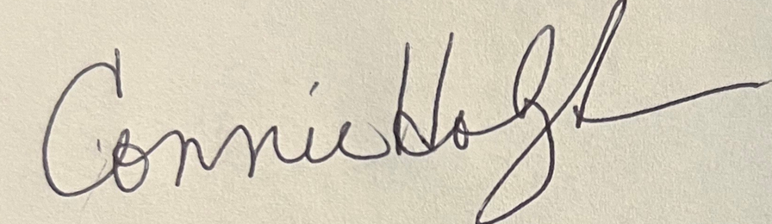
Date 10/28/2025

Lorie Hacker, 2025 Province Chairman

_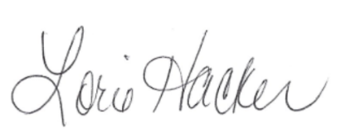__

Date ___10/28/25____________

Evonne Albert, Theta Province Assigned Officer

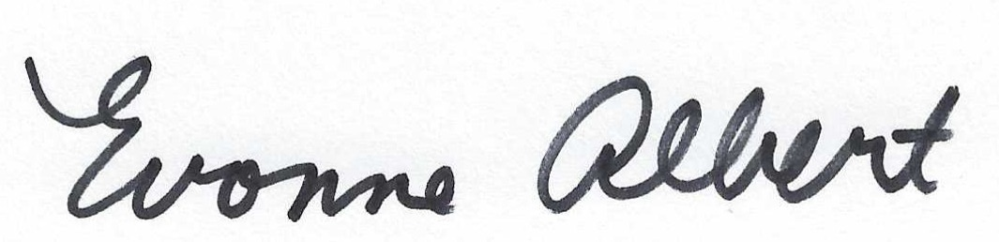

Date 10/30/2025

FINANCIAL REPORT OF THETA PROVINCE
DELTA THETA TAU SORORITY, INC.
October 3, 2025

PHILANTHROPY GENERAL TOTAL
Balance received from previous chairman 50.07 50.07
2025 Province fees ($3.00 x 171 members) 513.00 513.00
20225 Province fees ($1.00 x 171 members) 171.00 171.00
Fines 15.00 15.00
Standing Rules 0
Donations 0
Interest .03 .03
TOTAL RECEIPTS $513.00 $236.10 $749.10

DISBURSEMENTS
Award Certificates 9.00
Postage .00
Printing .00
TOTAL DISBURSEMENTS $9.00

General Fund Balance as of 2024 $227.10
Transfer from General Fund - 177.00
Philanthropy Fund + $177.00 ________
$690.00 $ 50.10

Convention Receipts for Philanthropy:
Kris Trapp $50.00
Julie Callis $150.00
Doris Sanders $25.00
Jennifer Ridgeway $50.00
Cynthia Brooks $50.00
Evonne Albert $25.00
Debi Hamblet $60.00

Total Receipts Towards Philanthropy $1,100.00

Post Convention Payments:
2025 Philanthropy Project
SAWS $367.00
IN Donor Network $366.00
Teachers Warehouse $367.00

